Read me: How to start reference implementation

# Step 1: Setup goal

1: First download goal from: <http://mmi.tudelft.nl/trac/goal/wiki/Releases>

Any goal version should work however the version our engine was tested with is: **goal20130319v5590.jar**

2: Install goal

3: Setup our environment, move the file **XmasEnvironment.jar** into the folder where you installed GOAL under: **GOAL\environment** folder.

4: Run goal

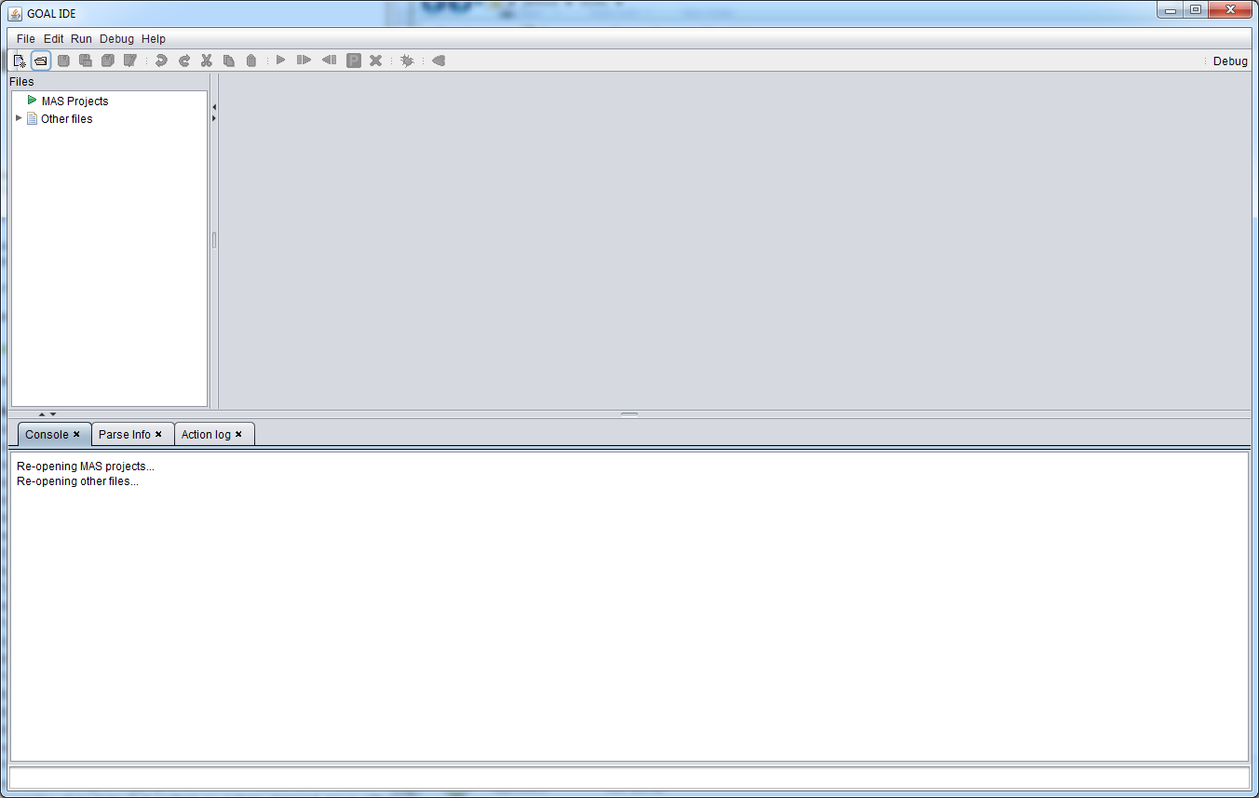

The screen you should be met with should look something like this.

# Step 2: Start the reference implementation

1: Run the file **ConsoleXmasImplementation.exe**

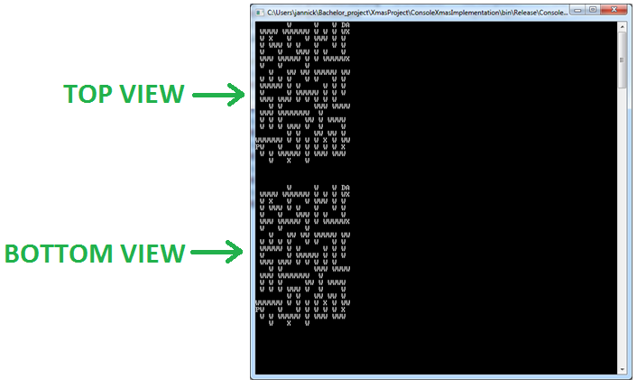

You should be seeing this screen; the top view will show what the agent sees while the bottom view will show the entire map. However the top view will only activate once an agent has connected.

There is also in the corner of the map a player agent P, this can be controlled by the keyboard using W, A, S and D for controlling it.

# Step 3: Connect GOAL to the reference implementation

1: In the GOAL program, open the **GrabberAgent.mas2g** file that we provide. This should by itself also open the **GrabberAgent.goal** file, double click the GraberAgent.goal to the code appear

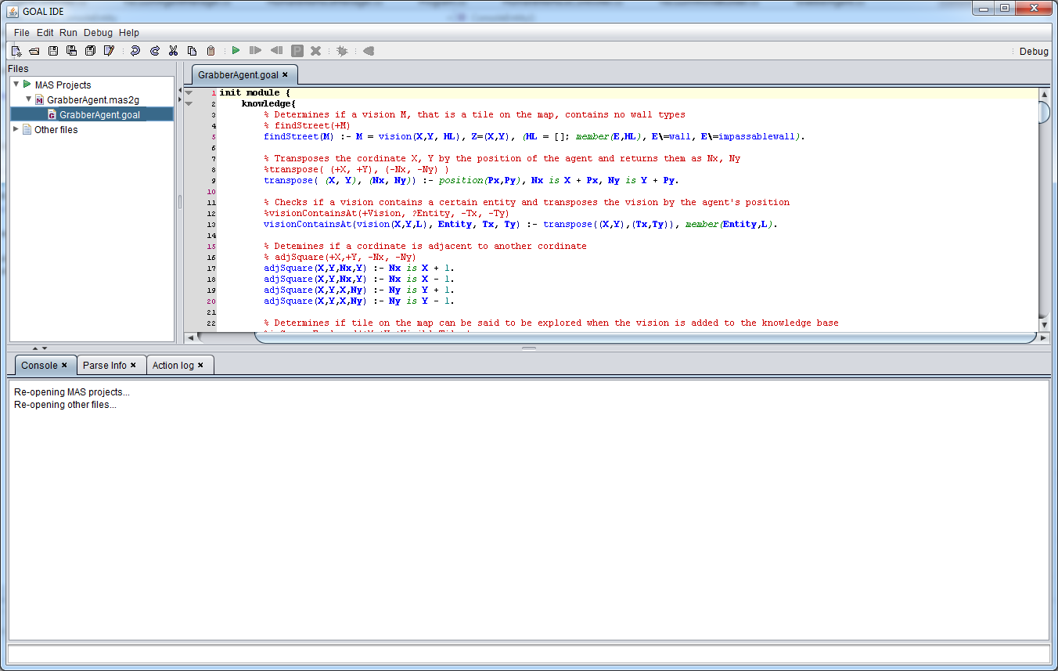

2: Click the green arrow to start the program.

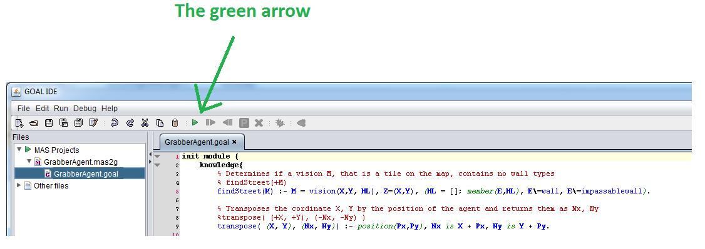

3: Select the GrabberAgent.mas2g then click the green arrow again.

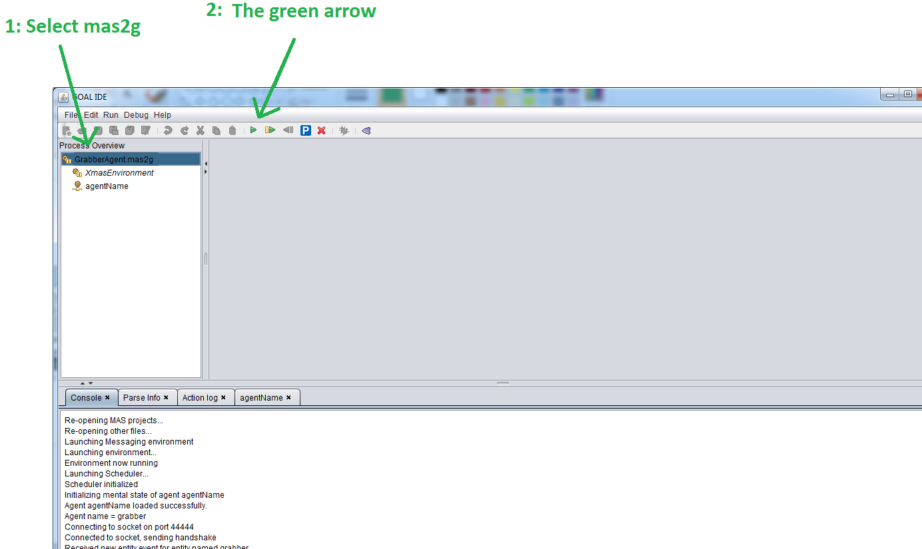

# Step 4: Watch the program execute

The program should now execute correctly showing the agent moving around the map collecting packages.

